**Architecture Diagram**

# 

# Task Details

1. Sign in to AWS Management Console.
2. Create an S3 Source Bucket.
3. Create an S3 Target Bucket.
4. Enable Cross Region Replication and add rule for source bucket.
5. Validation of the Lab

# Lab Steps

## Task 1: Sign in to AWS Management Console

1. Click on the **Open Console** button, and you will get redirected to AWS Console in a new browser tab.
2. On the AWS sign-in page,
   * Leave the Account ID as default. Never edit/remove the 12 digit Account ID present in the AWS Console. otherwise, you cannot proceed with the lab.
   * Now copy your **User Name** and **Password** in the Lab Console to the **IAM Username and Password** in AWS Console and click on the **Sign in** button.
3. Once Signed In to the AWS Management Console, Make the default AWS Region as **US East (N. Virginia) us-east-1.**

## Task 2: Creating an S3 Source Bucket

In this task, we are going to create an S3 source bucket with the required configurations like name, region, access, and versioning.

1. Make sure you are in the **US East**(**N.Virginia) us-east-1** Region.
2. Navigate to the **Services** menu at the top. Click on **S3** in the **Storage** section.
3. In the S3 dashboard, click on the **Create bucket**button and fill in the bucket details.
4. In the General Configuration, Bucket name:Enter **whizsource1 (Source bucket)**
   * **Note:** S3 Bucket names are globally unique, choose a name that is available. Maybe you can enter your name and create one.
5. Region:Select **US East (N. Virginia) us-east-1**

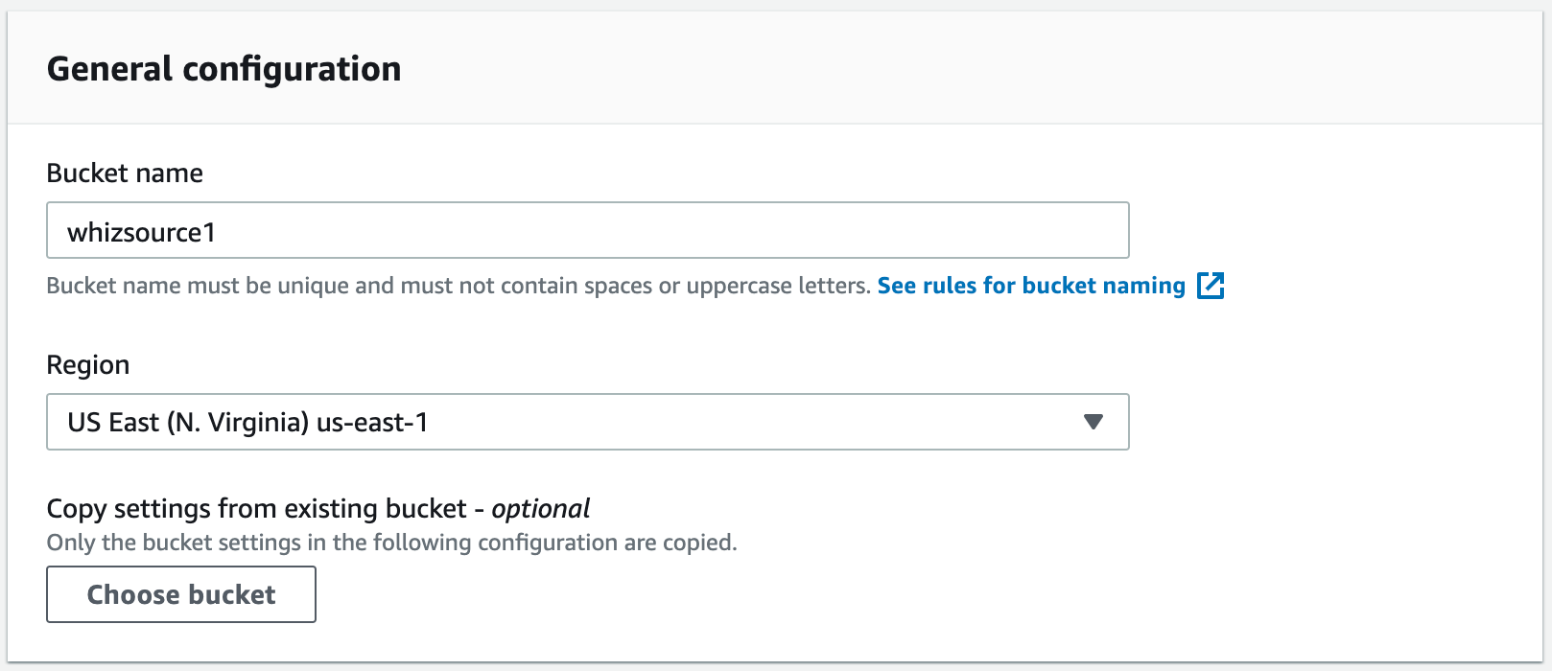

     6. Object ownership: Select **ACLs disabled (recommended)** option

     7. In the option of **Bucket settings for Block Public Access**, **Uncheck**the option of **Block all public access**. And, Acknowledge the same by checking the below option

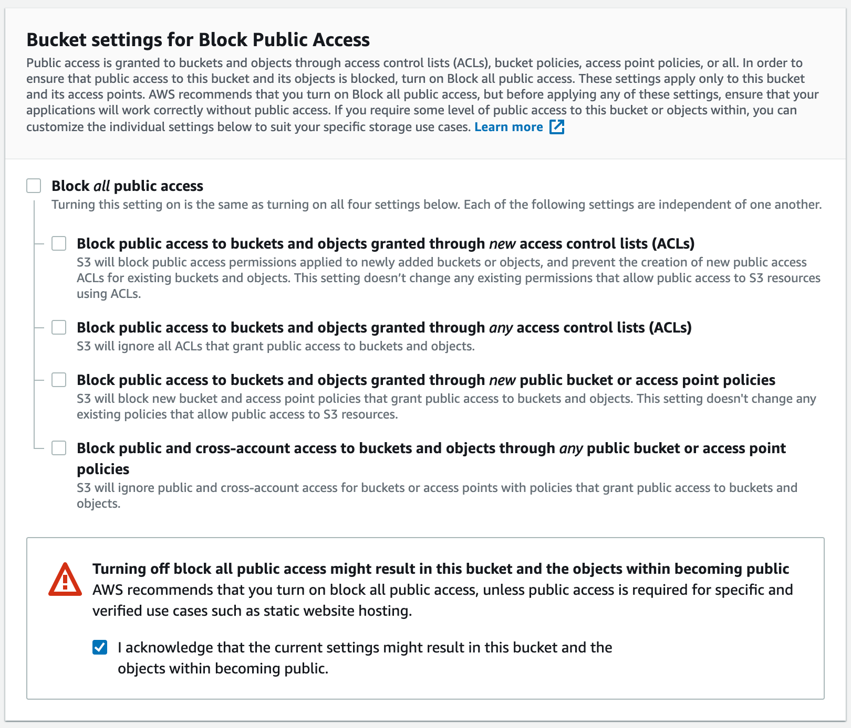

    8. In the Option of **Bucket Versioning,** Check the option of **Enable.**

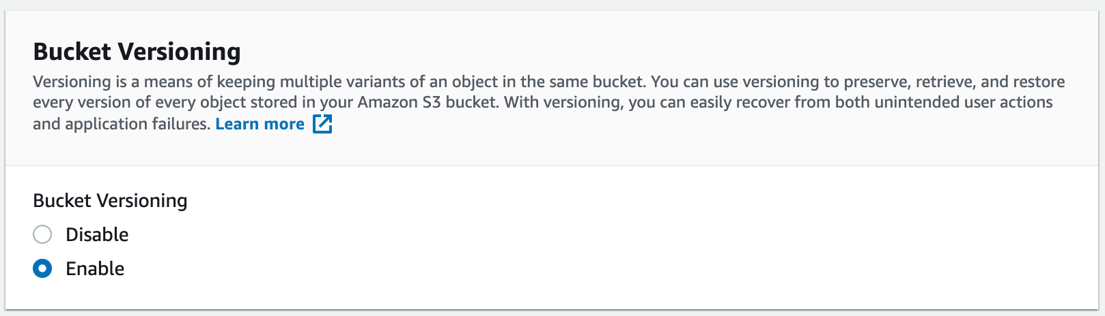

     9. Keep everything default and click on **Create bucket**button.

10. **Source bucket** is created now, Let's create the **target bucket**.

## Task 3: Creating an S3 Target Bucket

In this task, we are going to create an S3 target bucket with the required configurations like name, region, access, and versioning

1. In the S3 dashboard, click on the **Create bucket**button and fill in the bucket details.
2. In the General Configuration, Bucket name:Enter **whiztarget1 (Target bucket)**
   * **Note:** S3 Bucket names are globally unique, choose a name that is available.
3. Region:Select **Asia Pacific (Mumbai) ap-south-1**

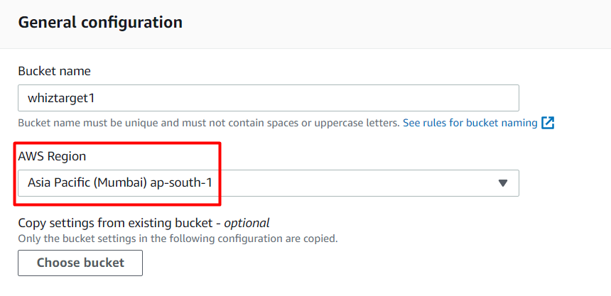

     4. Object ownership: Select **ACLs disabled (recommended)** option

     5. In the option of **Bucket settings for Block Public Access**, **Uncheck**the option of **Block all public access**. And, Acknowledge the same by checking the below option.



     6. In the Option of **Bucket Versioning,** Check the option of **Enable.**



1. Keep everything default and click on **Create bucket**button.
2. Both the **Source** and **Target** Buckets are created successfully.

## Task 4: Enable Replication in Source Bucket and add a rule

In this task, we are going to create a replication rule for the source bucket and will specify the destination bucket.

1. Now go to **Source Bucket** and click on **Management.** Scroll down and select **Create replication rule**button.
2. Enter a rule name of your choice and keep the status as **Enabled**.

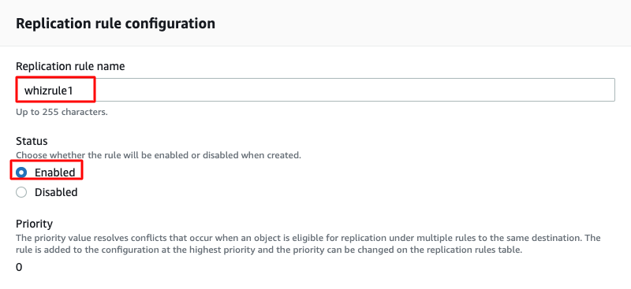

1. Choose a rule scope : Select **Apply to all objects in the bucket**

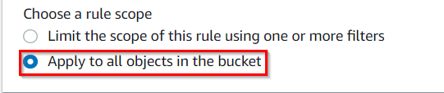

1. Under Destination, select **choose a bucket in this account** and click on **Browse S3**.

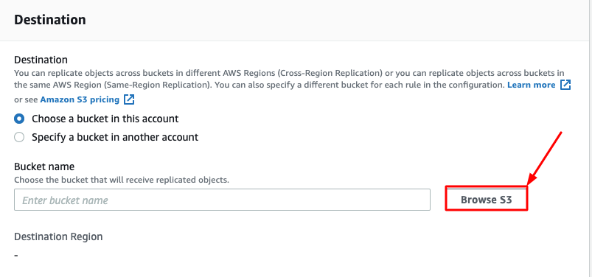

1. Select the target bucket created earlier and click on **Choose path**button.



1. Under IAM Role, Select Choose from existing IAM roles and select **Create new role**.

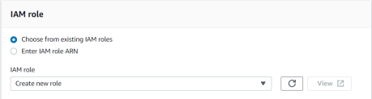

    7. Under the Destination Storage Class, select **Change the storage class for the replicated objects** and choose **One Zone-IA**.

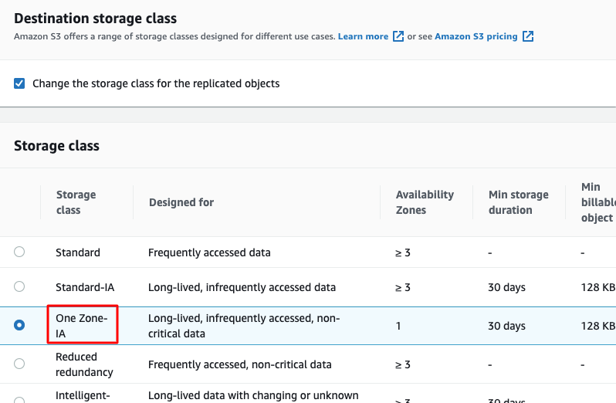

    8. Leave everything as default. Review once and click on **Save**button. One Pop-up appears Select **No, do not replicate existing objects** and Click on **Submit** button.

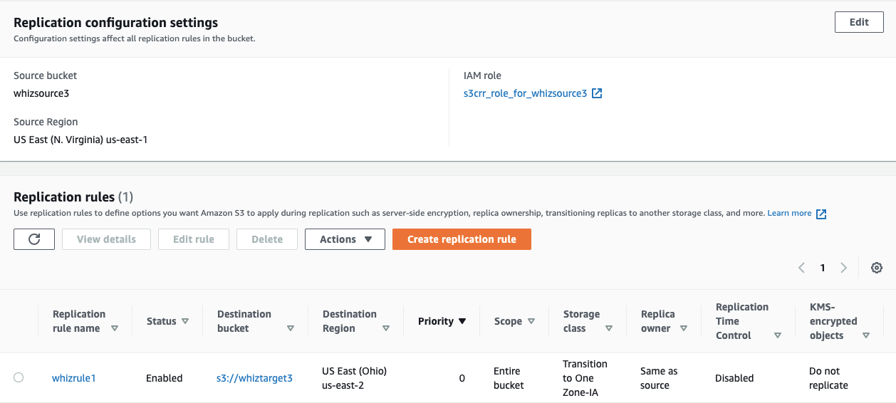

    9. Now navigate to the source bucket and upload an Object(.txt or .png) in the **Source bucket** by clicking on Add Files. Click on **Upload**.

   10. Click on the **Add files**button and upload any object from your local machine and click on **Upload**button.

   11. Navigate to your **Target Bucket** to see the replication. It may take **up to 3-5 minutes** for replication.

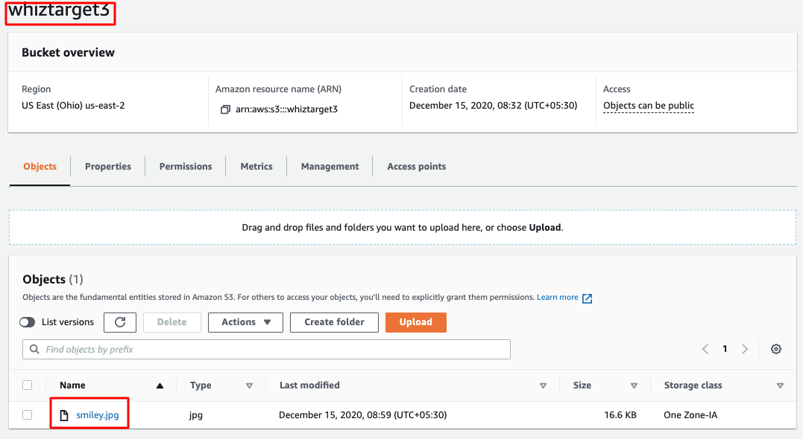

    12. Now you have successfully configured the Cross-Region Replication in S3 Bucket. Congratulations!

## Task 5: Validation Test

1. Once the lab steps are completed, please click on the **Validation** button on the left side panel.
2. This will validate the resources in the AWS account and show you whether you have completed this lab successfully or not.
3. Sample output:

